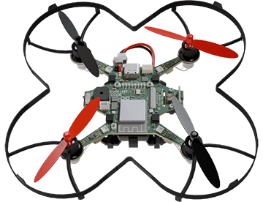

|  |  |
| --- | --- |
| **CodeAIR Mission 7 Assignment** | **Name:** |
| **Pre-Mission Preparation** | |
| What do you remember about blocking functions? Give an example. |  |
| What do you remember about non-blocking functions? Give an example. |  |
| **Mission 7 Checks – Multitasking** | |
| Objective #1  What does “sequentially” mean?  Click on scheduler. What does the task scheduler let you do?  What type of tasks can be scheduled?  What StateMachine function is used to register a callback function?  What is the difference between **pixels.off** and **pixels.off()**? |  |
|  |
|  |
|  |
|  |
| Objective #2  How do you add another task to the scheduler? |  |
| Objective #3  What are some common scheduling blockers?  What will the StateMachine do if a task takes too long?  Use CodeTrek to add code to your program. Before you run the code, predict what you think will happen. |  |
|  |
|  |
| Objective #4  How do you turn a blocking function like speaker.beep() into a non-blocking function?  What function will run a function just once after a specific delay? |  |
|  |
| Objective #5  How do you make a sensor check non-blocking?  What is the exception to the non-blocking sensor check? |  |
|  |
| **Post-Mission Reflection** | |
| A lot of new coding concepts were introduced during this lesson. List at least three new things you learned or used in your program. |  |
| How do you think you will use these concepts and coding functions in future missions? |  |